Craig’s Affliction
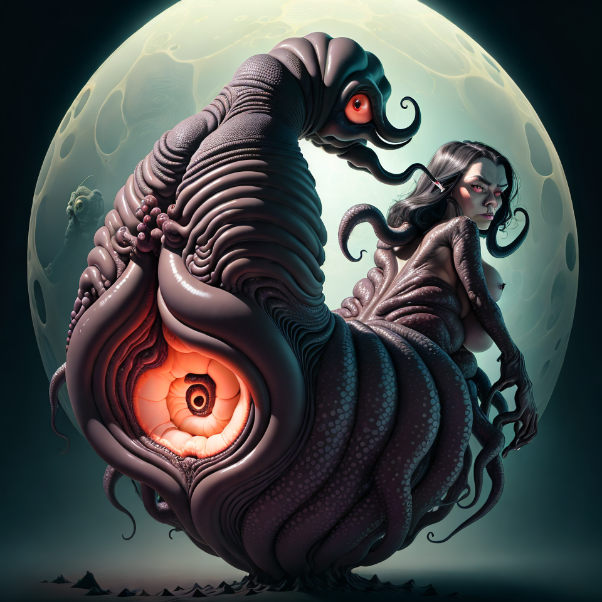

I guess this story’s been festering in my brain for long enough. Whether I should tell it or just let it rot doesn’t really matter anymore. And yeah, I get it—this might sound like I’m making fun of Craig, but that’s not it. This is about one of my best friends, a guy who lived life on the edge of ridiculous, just like me. We had a lot of preposterous, inappropriate adventures together—ones that could either make you laugh or cry depending on how fucked up your sense of humor is.

Ever since Craig died, I’ve wondered if I should even bother putting this out there. But the other day, I was reminiscing with a buddy, and I realized: Who the fuck cares? Craig sure wouldn’t. He’d be the first to laugh and say, “Tell the damn story.” Craig didn’t give a rat’s ass about anyone’s judgment, so why the fuck should I?

So here it is—the tale of Craig’s hemorrhoids and the summer from hell we spent in Wyoming.

I don’t remember the exact year—early 2000s, somewhere in the wasteland of 2004. I was in my early twenties, and at that point in life where everything feels like it’s spinning out of control, but you’re too fucked up on booze and bad decisions to care. I was dating Mags, and we were deep in the shit that was Gillette, Wyoming. If you’ve ever been to Gillette, you know it’s the kind of place where bad decisions go to die, and life just sort of grinds to a halt.

Most of the stories from that time intersect in some way, but this one? This one stands out. It all started before then, though, and I can trace it back to the first time we hit up this shitty Mexican restaurant in Rapid City. That place—fuck me—set off a chain of events that landed us where we were, and if I believed in any sort of cosmic cause-and-effect bullshit, I’d say the universe was trying to make a point. But since the story has to start somewhere, let’s kick it off the night we were playing a bluegrass concert in a bar owned by a friend.

Now, this wasn’t just any bar. This was the same bar where I once made people drink piss, or at least watch them drink it, unwillingly. The same place where I’ve seen way too many naked assholes for one lifetime, and the same bar where, in hindsight, Craig probably started the downward spiral that eventually led to his early demise.

Me, Steve, and Jason had already started the set. We were waiting on Craig because he had to work late. The dude’s work ethic was beyond ridiculous. Even at his own funeral, we joked that Craig would’ve been pissed at anyone who missed a shift to be there. He’d have called us all lazy fuckers for daring to skip work just to bury him.

So there we were, half-drunk, halfway through a bottle of Wild Turkey, playing to a small crowd that was mostly tolerating us because they were too buzzed to care. I think I’ve got photos from that night somewhere—I’ll shove them in here later. Then, about three songs in, Craig comes barreling through the door, yelling, “I’m fucking here!”

The crowd, drunk and sloppy, lit up because everyone loved Craig. He had that kind of presence—like he could walk into a room and make everyone think they’d known him forever. He picked up his bass—yeah, the one made out of a gas tank and weed whacker line—and jumped right in with our fast, sloppy bluegrass punk bullshit.

Now, from what I remember, the show actually went pretty well. People seemed to dig it, or maybe they were just too fucked up to hate it. Doesn’t matter. My blood alcohol level was never under 0.4 in those days, so my memories of that night are about as reliable as a dollar store condom.

But there’s one thing I do remember clearly: Craig was scratching his ass the whole goddamn time. At first, I figured he just had swamp ass from getting off his restaurant shift. Who hasn’t been there? But this was different. Craig wasn’t just uncomfortable—he was in pain. The look on his face wasn’t just the usual drunk-and-sweaty misery. It was more like, “My asshole is on fire and I might just fucking die right here.”

So, Craig is there, scratching his ass like it’s about to fall off, and I’m starting to notice. Now, normally, I wouldn’t give a shit—who hasn’t dealt with a little swamp ass after a long day? But this was different. Craig wasn’t just doing the casual “my ass itches” shuffle. No, he was grimacing, like his entire lower half was plotting some kind of revolt.

We finish the set, and we’re all sweaty and half-drunk. As usual, I’m pissed at everything—pissed at the bar, pissed at the shitty crowd, and most of all, pissed that Craig might’ve been fucking up songs while we played. So I confront him.

“What the fuck’s wrong with you?” I ask, thinking maybe he’s just too drunk to play right. And that’s when Craig hits me with it.

“My ass hurts like hell, man. I’ve got these bumps—hemorrhoids or something,” he says, like he’s admitting to a murder.

Now, keep in mind, I was in my early twenties. My knowledge of hemorrhoids was limited to “old people problems” and maybe something about sitting on cold concrete for too long. I was a high school dropout with a GED, full of pseudo-scientific bullshit and just enough redneck South Dakota know-how to make me dangerous. Hydrodynamics? Peristaltic propulsion? Fuck no. At that point, I barely knew how my own asshole worked, let alone how to help Craig with his.

So, like any responsible friend, I told him to suck it up. “You’ve got hemorrhoids? Big fucking deal. You don’t stop playing because your ass hurts.”

In hindsight, maybe I should’ve been more sympathetic, but let’s be real—I wasn’t in the business of compassion back then. I just wanted him to stop messing up the songs. Craig, being the laid-back guy he was, just shrugged it off and said he had some kind of cream for it.

And that was it. We kept drinking, kept playing, and honestly, I didn’t think much more about it. Craig was always doing gross shit, and at the time, this was just one more thing in a long line of weird, disgusting crap we were too drunk to care about. But it stuck in my head as the first real memory of Craig’s ass troubles.

Time marched on, and so did Craig’s hemorrhoids. By this point, we’d all been unemployed for a while—just drifting through life, mooching off Steve’s free booze from the hotel bar where he worked, and pretending like we had any fucking clue what we were doing. We had band practice all the time, mostly because we didn’t have anything else to do. Life was this weird, booze-soaked routine of playing music, drinking ourselves stupid, and avoiding any sort of real responsibility.

Craig, though? Craig was still bitching about his ass. Every band practice, every hangout—he’d bring it up. “Man, my butt’s killing me,” he’d say, and we’d all kind of nod along because, fuck it, we were young. We didn’t know shit about hemorrhoids. Hell, the only people I knew who had hemorrhoids were pregnant women, and they sure as shit weren’t talking to me about it.

I think Jason was the oldest of us, maybe 30 at the time, and even he didn’t know anything about hemorrhoids. We were all flying blind, making jokes and shrugging it off like it was nothing. But Craig? Craig was dealing with some next-level ass pain, and none of us had any clue how bad it was.

So, the summer continues, and we find ourselves in Wyoming, working at one of Craig’s dad’s restaurants. It was one of those bizarre jobs that felt like it came out of nowhere, but hey, it was a paycheck. The oil boom had turned Wyoming into this fucked-up gold rush for roughnecks, and real estate prices were through the roof. Craig’s dad had bought a meth house, but we weren’t allowed to move in yet, so they stuck us in a tiny-ass camper.

Now, when I say tiny, I mean tiny. This camper was barely big enough for one person, let alone two drunk idiots with a blood alcohol level that probably crested 0.4 on any given night. We were constantly trashed, and under a fuck-ton of stress, so naturally, we started fighting about dumb shit.

One night, Craig had enough of my “get over it” attitude about his ass. “You don’t know what the fuck I’m dealing with,” he says. “You wanna see?”

“No, Craig. I don’t give a fuck about your hemorrhoids,” I replied, already tired of the conversation that had been going on for weeks.

But Craig, being Craig, decided that the best way to prove a point was to drop his pants and show me the horror.

What I saw was worse than I ever could’ve imagined. It wasn’t just hemorrhoids. It was something straight out of a nightmare. His asshole had swollen—like, massively swollen. It looked like someone had tried to beat the shit out of it with a hammer and then just left it there to fester. And the worst part? There was this labia-like fold around the whole thing, like his rectum had grown a second set of lips.

I could barely look at it. I’m telling you, Craig’s ass looked like it had been through a meat grinder. “Oh, fuck,” I muttered. “That’s a problem.”

Time keeps dragging us through one fucked-up scenario after another. By now, we were living like two degenerate hobos in that tiny camper, working at Craig’s dad’s restaurant, drinking our weight in booze every night, and—of course—dealing with Craig’s goddamn hemorrhoids. It had become a regular part of our lives, like some kind of sick joke the universe was playing on us.

Craig’s ass, though? It wasn’t laughing. It was getting worse. And worse. He kept complaining during band practice, bitching about his hemorrhoids every time we saw him. At this point, it had been months of Craig whining about his ass, but we were all still too young and stupid to do anything about it. We’d just laugh it off and tell him to eat more vegetables, like that was gonna fix whatever the fuck was going on back there.

But this wasn’t some minor, itchy-ass, hemorrhoid situation. Oh no. Craig was walking around with a fucking ticking time bomb between his cheeks, and none of us had any clue just how bad it was.

One night, we were sitting in that cramped, piss-smelling camper, drunk as shit—again—when Craig finally hit his breaking point. “You wanna know what I’ve been going through?” he shouted, halfway through another argument.

Before I could even respond, Craig stood up, turned around, and dropped his pants. And holy. fucking. shit.

What was staring back at me wasn’t just a hemorrhoid problem. It was like the gates of hell had opened up, and the devil himself had decided to take up residence in Craig’s ass. His rectum looked like some kind of grotesque, fleshy flower—swollen, raw, and honestly, just fucking wrong. There were these disgusting, flabby folds around the whole thing, like his asshole had tried to grow a vagina.

I don’t even know what the fuck I was looking at, but I do know I never wanted to see anything like it again. “Jesus Christ, Craig,” I muttered, trying not to throw up. “That’s not hemorrhoids. That’s some next-level, ass-fucked nightmare.”

Craig, of course, shrugged it off like it was just another shitty day at the office. “Yeah, it’s been pretty bad.”

Pretty bad? The man’s asshole looked like it had been through a war, and he was talking about it like it was a mild inconvenience. Meanwhile, I’m sitting there, staring at the literal worst thing I’ve ever seen in my life, trying to figure out how the hell we ended up here.

So, Craig’s got this prolapsed nightmare between his cheeks, and we’re all just trying to pretend like life’s still normal, which, spoiler alert: it wasn’t. His ass had gone from “minor inconvenience” to “fucking horror show,” and the dude was still walking around, working shifts, drinking with us, and somehow functioning. Honestly, it was impressive. If it were me, I’d have checked myself into a hospital and begged them to just rip my asshole out entirely. But Craig? Nah, he kept going, like his ass wasn’t about to stage a revolt.

A few weeks later, we find ourselves in the middle of nowhere, Wyoming, at one of our usual bonfire parties. The kind where we’d do a stupid amount of drugs, play some music, and generally act like feral animals. Craig’s been whining about his ass more and more, but at this point, we’re all numb to it. It’s like background noise—“My butt hurts.” Yeah, we fucking know, Craig. Join the club.

But this night? This night was different. It was the night the “Ass Squid” was born.

We’re all sitting around, high as fuck, passing around drinks and joints, when Craig starts in again, complaining about his hemorrhoids. Except this time, he wasn’t just complaining—he was fed up. “I can’t take this shit anymore,” he says, standing up in the middle of the group. Before any of us could stop him, he did it again—he drops his pants and shows us what was left of his poor, abused asshole.

And holy shit. I wish I could unsee it, but that image is burned into my brain for life.

Craig’s asshole didn’t just look bad anymore. It looked like it was alive. Swollen, flabby folds hung off his rectum like tentacles. One of the guys at the party, Jason, stared at it for a second and then screamed, “It’s a fucking squid! It’s got tentacles!”

The whole group erupted in chaos. Everyone’s freaking out—veterans, drug addicts, hippies, people who’ve seen some serious shit—and here they are, recoiling in horror at Craig’s ass. One dude was so high, he swore he saw the thing wink at him. “Oh my God, it fucking winked! It’s trying to kill me!”

At that moment, I was convinced I’d finally gone insane. Craig’s prolapsed rectum looked like it was straight-up attacking us, and I wanted nothing more than to run as far away as possible. But the thing about fucked-up situations? They suck you in.

Finally, one of our friends yells, “Craig, go to the fucking doctor. We’ll pay for it. Everyone, pass the hat—we’re paying for Craig’s ass surgery.”

The whole party rallied together, passing around a hat full of crumpled-up bills and spare change, all of us in complete agreement: Craig’s ass had reached a level of horror none of us could deal with anymore. It was time for professional help. The man was bleeding on bar stools, for fuck’s sake.

After that night, it was clear to everyone—Craig had to get his ass checked out by a professional. It wasn’t just the tentacle-like monstrosity we’d all witnessed; it was the blood, the constant complaints, and the fact that the poor bastard was practically oozing misery from every pore. We couldn’t just let him keep walking around like that. So, after we sobered up (which took a while), we all made sure Craig got his ass to the Mayo Clinic.

Craig, being Craig, tried to shrug the whole thing off like it wasn’t that bad. But I knew. We all fucking knew—his ass was a war zone, and he needed medical intervention, stat. So, off he went, and the rest of us just continued our sad, drunk existence in Wyoming, pounding down veggies like they were going to save us from Craig’s fate. Spoiler: no amount of broccoli was going to keep us from ending up in the same ass apocalypse, but we tried anyway.

A few days later, my phone rings. It’s Craig.

“Hey, man,” he says, and I can already tell by the tone of his voice that something’s up. “Turns out it wasn’t hemorrhoids after all.”

Now, I don’t know what I was expecting, but it wasn’t this. “What the fuck do you mean, it wasn’t hemorrhoids?”

“Yeah,” Craig says, sounding way too calm for someone who just had his entire ass problem re-diagnosed. “Turns out I’ve got HPV. Like, the worst fucking case they’ve ever seen at the Mayo Clinic.”

I’m stunned. HPV? I mean, sure, I’d heard of it, but back then, nobody was really talking about it. Everyone probably had it, but it wasn’t exactly common knowledge like it is now. And Craig? Craig had it bad.

My mind raced with questions, and, being the idiot I was, I asked the most moronic one possible. “So... did some chick’s pussy juice run down into your ass crack or something? How the hell do you get HPV there?”

Craig just sighed. “No, man, it’s not like that. I guess I picked it up from some girl. Or something like that. Fuck if I know.”

And that was that. Craig had rectal HPV, not hemorrhoids. And apparently, it was so bad that they had to use lasers to burn the warts out of his asshole. Pre-cancerous, too. The guy had been walking around with his ass falling apart and had no idea how close he’d come to something a hell of a lot worse than we thought.

So Craig gets back from the Mayo Clinic, and the guy’s acting like he just got his teeth cleaned. No big deal, just had lasers burn pre-cancerous warts off his ass. But, of course, the rest of us? We couldn’t let this shit go.

The news spread fast, as it always did in our circle of degenerates. I swear, within seconds of Craig calling me, the whole fucking town knew. It was like some kind of cosmic joke. Craig thought he was having a private conversation with me about his HPV diagnosis, and before the phone had even cooled down, people were whispering, “Hey, did you hear about Craig? Turns out he didn’t have hemorrhoids—he had warts. They torched that shit out of him with fucking lasers.”

It didn’t take long before everyone had some joke lined up for Craig. “So, what did you put in your ass, Craig?” Jason cracked one day, followed by, “That’s why they make those things dishwasher-safe, man.” Craig, in his typical laid-back way, just rolled with it. If there was anyone who could take a joke about their ruined asshole, it was Craig.

But even with the laser-wart-surgery jokes, we never really talked about it again. It was like an unspoken agreement. Craig was cool with laughing about it, but nobody dug deeper. After all, we’d seen more of Craig’s asshole than anyone ever should, and maybe that was enough. There was no need to keep that trauma alive.

Life went on, as it does. More shows, more booze, more bullshit Wyoming stories that would’ve gotten us all arrested if anyone had been paying attention. Craig’s ass healed up—at least as much as it could after getting shot up with lasers—and everything went back to the new normal. I’ll always remember how casual he was about the whole thing, like almost losing your ass to HPV was just another day in the life.

So, I guess if there’s any lesson here (I’m not great with lessons), it’s this: if your ass starts to hurt, don’t fuck around. Go to the doctor. And maybe—just maybe—don’t tell your bartender about it. And for fuck’s sake, that’s why they make those things dishwasher-safe.

